How can we materialise the views?

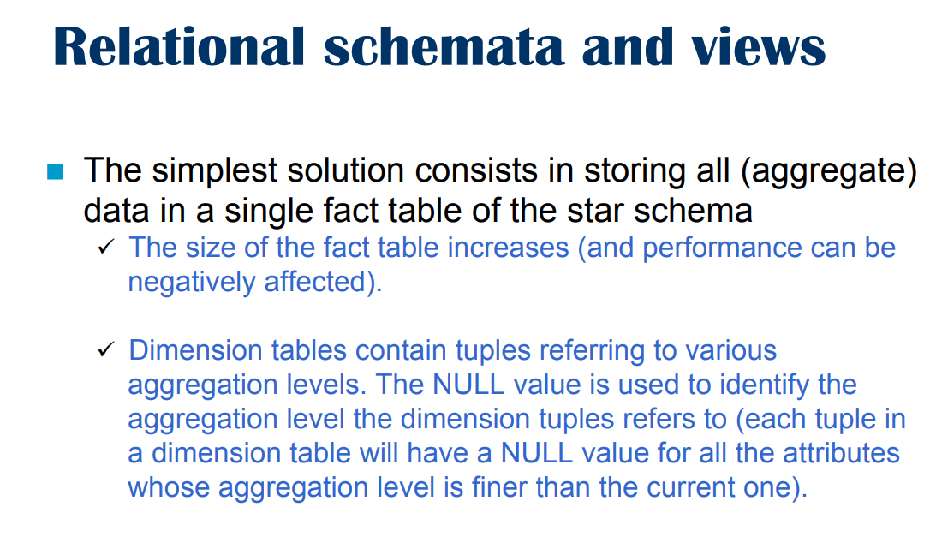
Simple solution: store every possible aggregate in the same fact table.

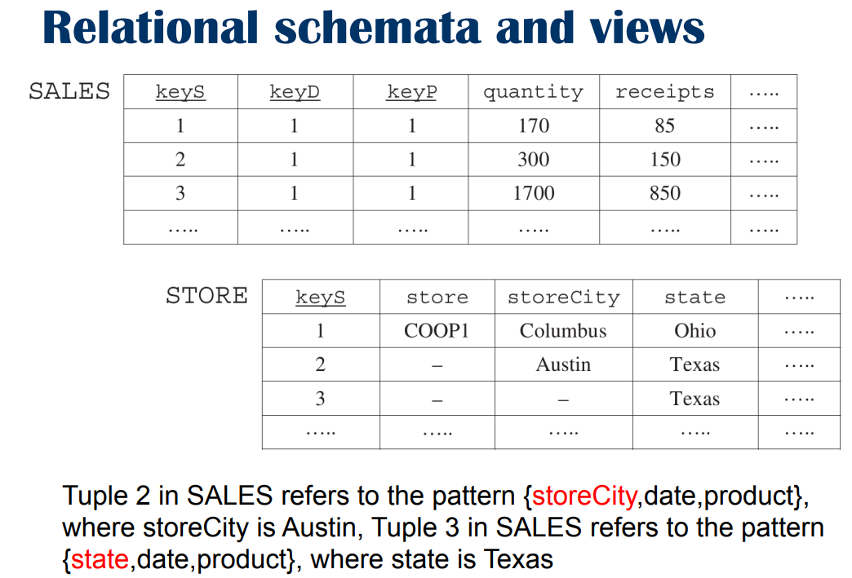
Fact table about sales, with primaryView we would have sales table and one table for each dimension (store, date, product) with the star schema.

Now in the same fact table I store other events too.

Store not only primary events but secondary events too.

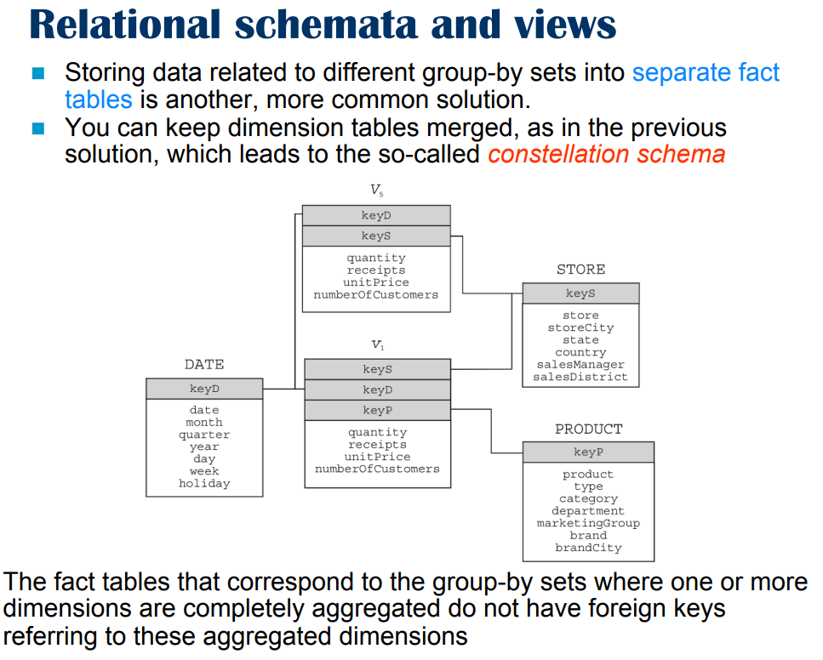

Other approaches. Store each view on a separate table. It is more common.

You create two fact tables. One called V₁ most granular level and the foreign keys are the one expected (store, date, product) but in this table we only have the primary events.

The other table, called V₂ contains a different view (in the screenshot is called V₅) it contains aggregation over products, the view contains events identified only by date and store dimensions (because product was aggregated). The data inside V₅ will still use one table for each dimension (2).

⟹ the fact table becomes much smaller.

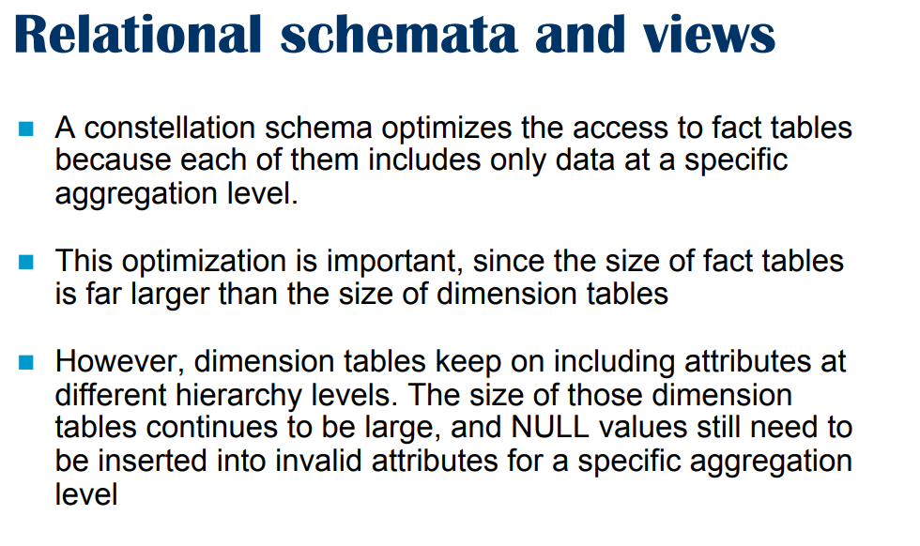

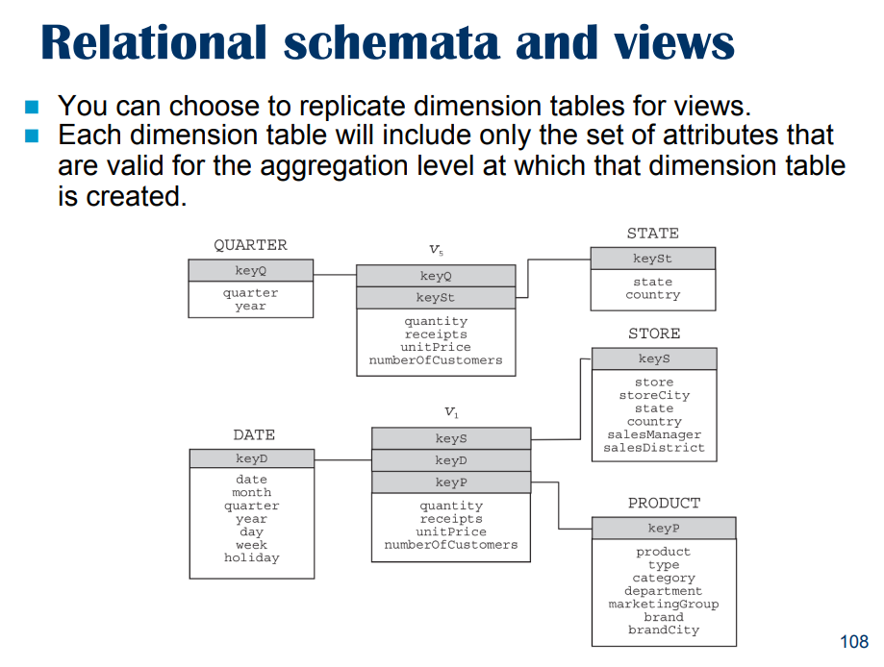
Duplicata table, for V₁ you have its own dimension table on the required granularity.

If you go in another view that aggregates product and aggregate data up to quarters and the store up to the state we create a view specific.

Is the best way to optimise data, minimum necessary to answer the query, if no other constraint this is the best way.

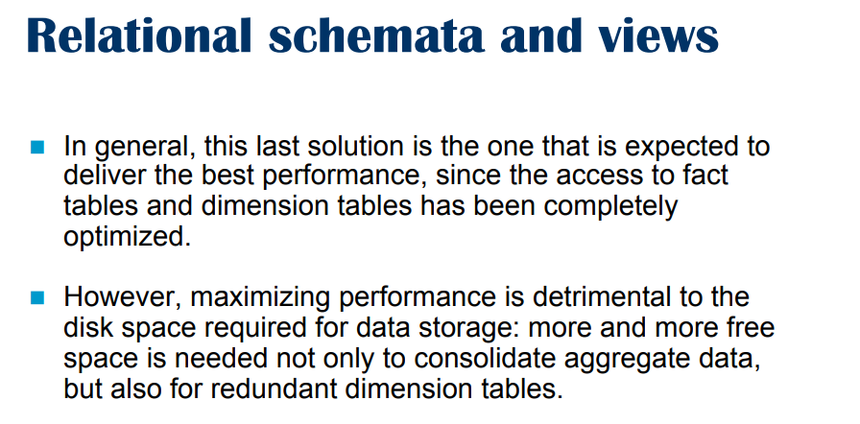
…but we duplicate the data :(

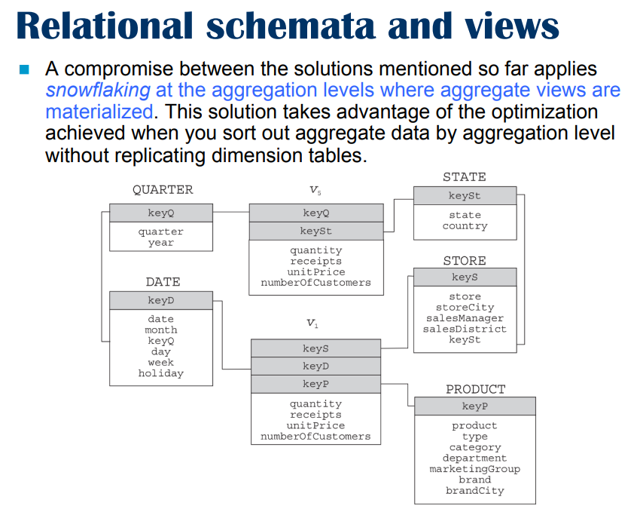
A compromise could be to use snowflake schema.
We still store the view independently, but now instead of duplicating the information now in the store dimension table we stop at store city nad we do not duplicate state and country.

We use a key to move to another table with state and country, In STORE I do not have state and country. We stop at some level and we have a foreign key to another table.

⟹ we reduce space usage rather than duplicate but we decrease performance.

This is the best overall approach

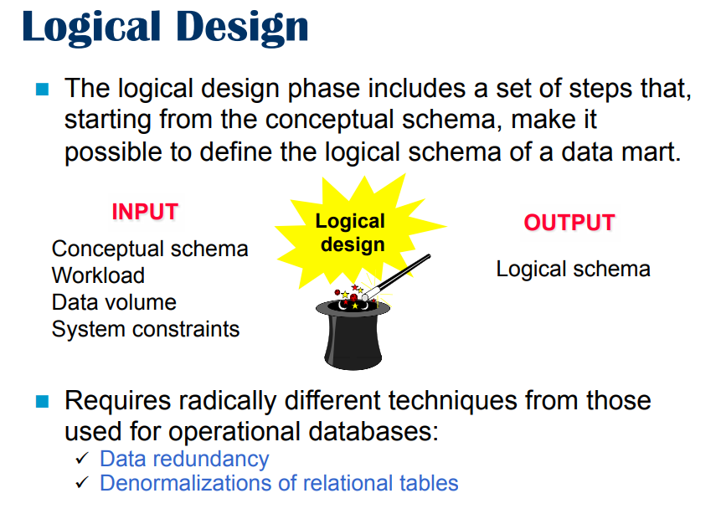Which approach do we choose?

We allow data redundancy and denormalize table to make query faster.

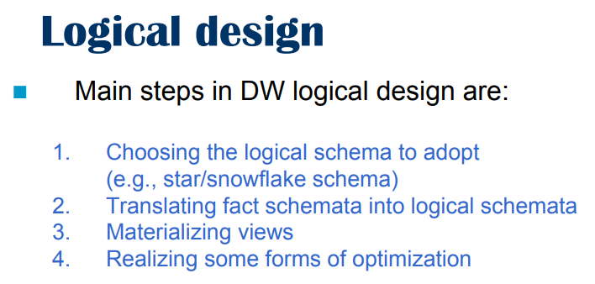

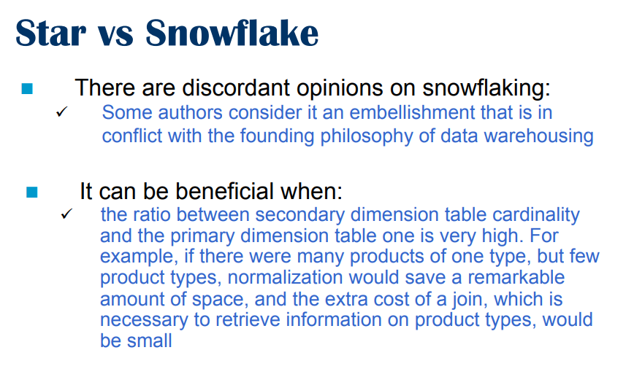
Million of products of view type ⟹ snowflake because secondary less aggregation

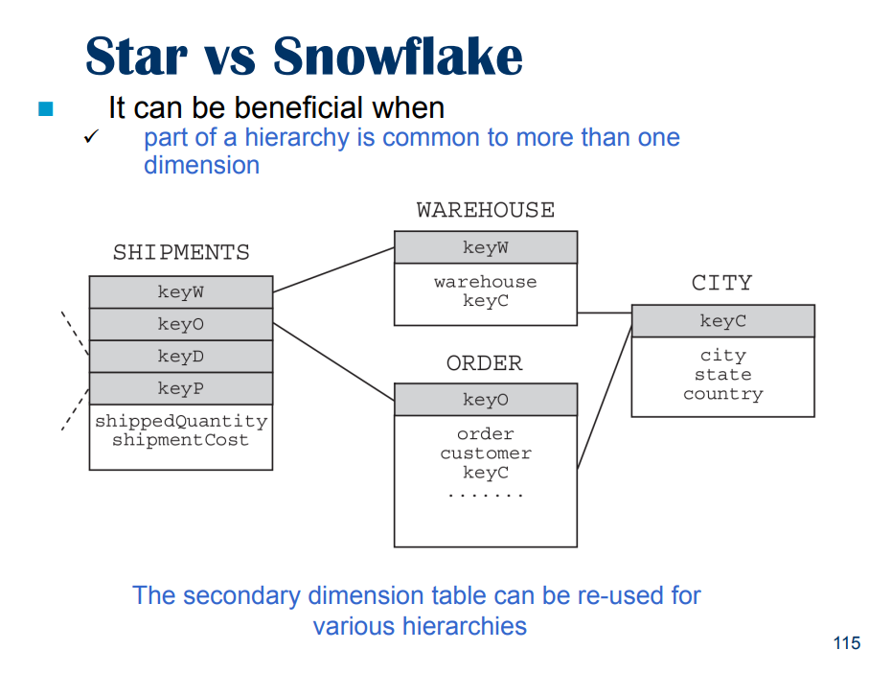
Snowflake with shared hierarchies.

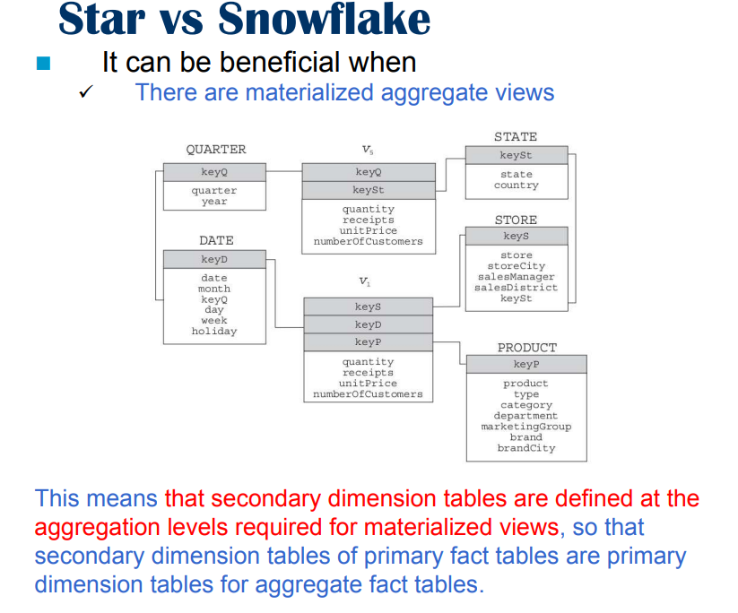

Use snowflake schema (main case) when you have a secondary view, better to give the table with the correct level of granularity.

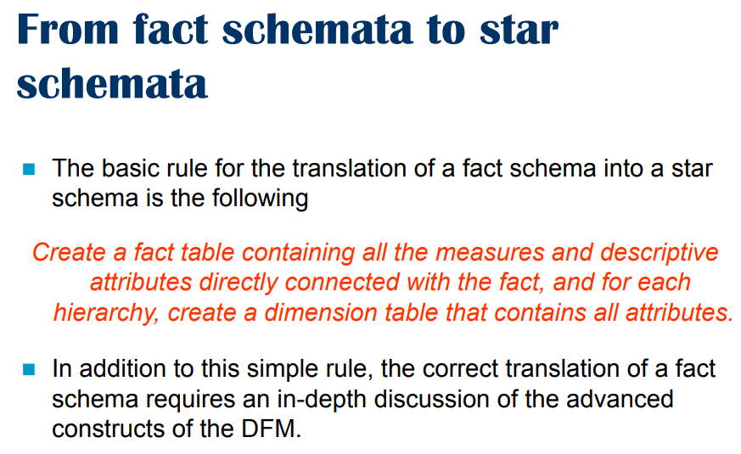
How usually create snowflake schema: create from a fact schema a star schema where the fact table contains the primary events with the measure and one dimensional table for each dimension hierarchy where all of the attributes of the hierarchy are in the same table. Then refine the schema

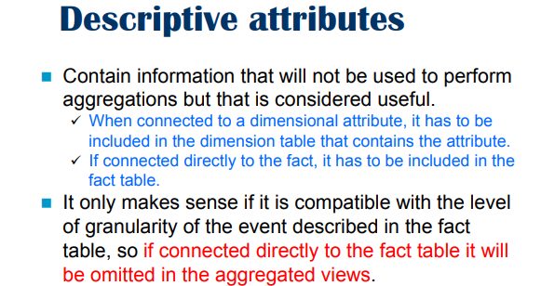

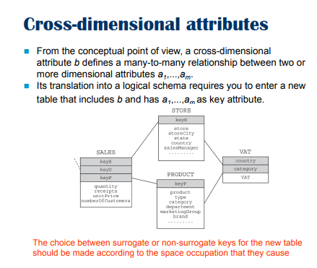

Ripredenre -59.00

